MOOC 4-MODULE 1
Unsupervised Machine Learning

I.Introduction to Unsupervised Learning: Overview
Unsupervised Learning Overview
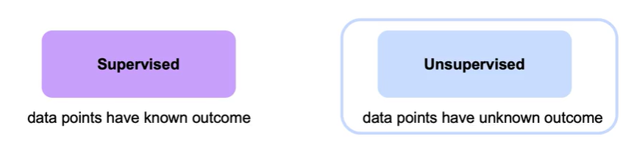
- Unsupervised learning is used when outcomes are unknown, aiming to find structures within datasets.
- Key applications include clustering (e.g., segmenting customers) and dimensionality reduction (e.g., reducing dataset size while retaining information).
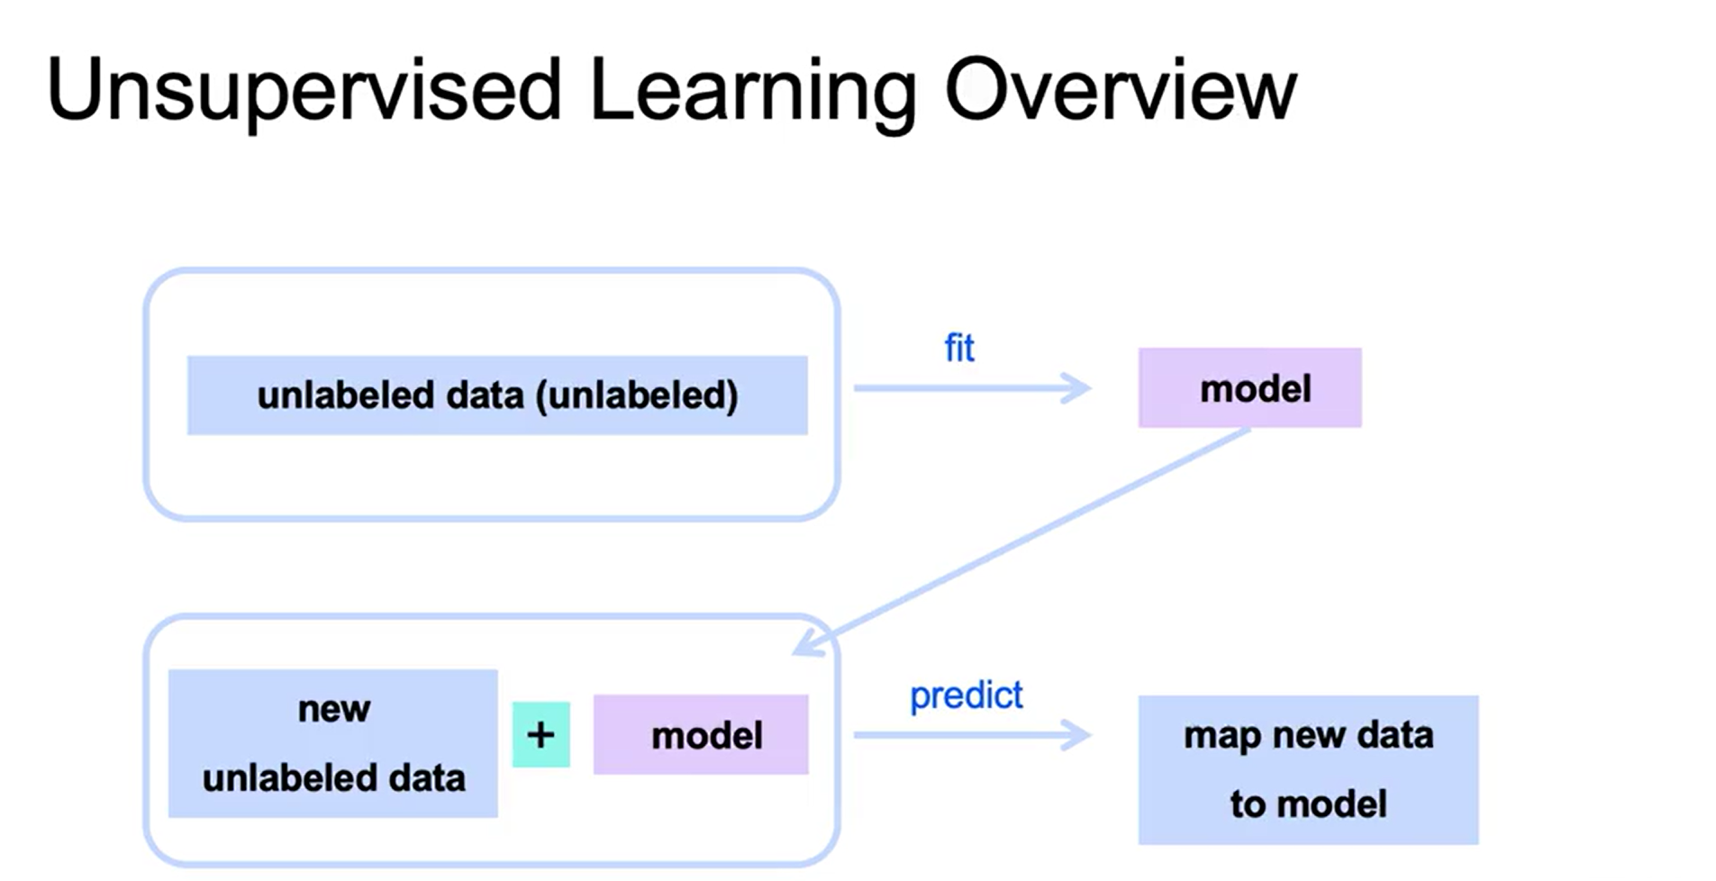
Clustering Algorithms
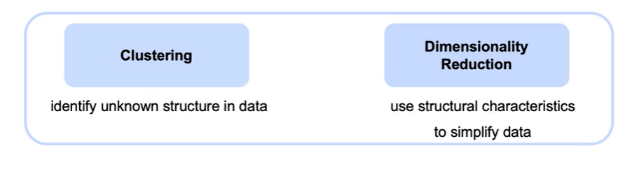
- The course covers several clustering algorithms: k-means, hierarchical agglomerative clustering, DBSCAN, and mean shift.
- These algorithms help identify unknown structures in unlabeled data.
Dimensionality Reduction
- Dimensionality reduction techniques, such as Principal Component Analysis (PCA) and non-negative matrix factorization, are discussed.
- The "curse of dimensionality" is explained, highlighting challenges with too many features, such as increased noise and the need for more training examples.
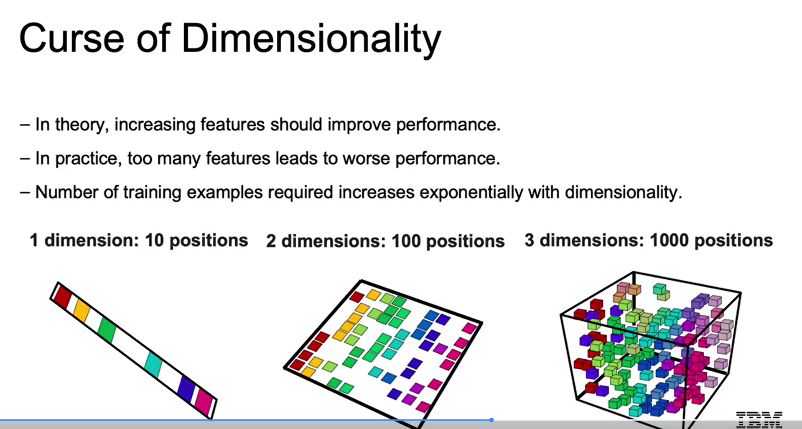
II.Use Cases of Clustering
Classification Use Cases
- Clustering can classify unlabeled data by identifying heterogeneous groupings within datasets, such as distinguishing spam emails from normal ones.
- It can also find subgroups in texts, like product reviews, to create different groupings.
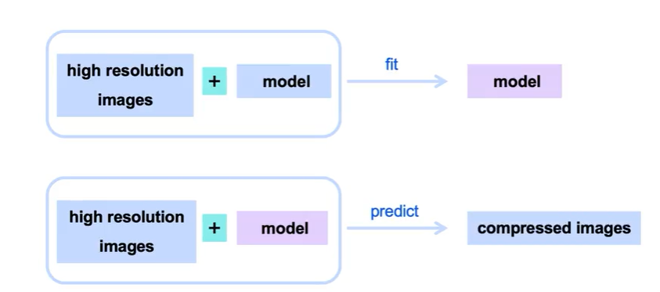
Anomaly Detection
- Clustering helps detect anomalies, such as unusual credit card transactions that differ significantly from a user's typical behavior, indicating potential fraud.
- This method identifies clusters of transactions that may require further investigation.
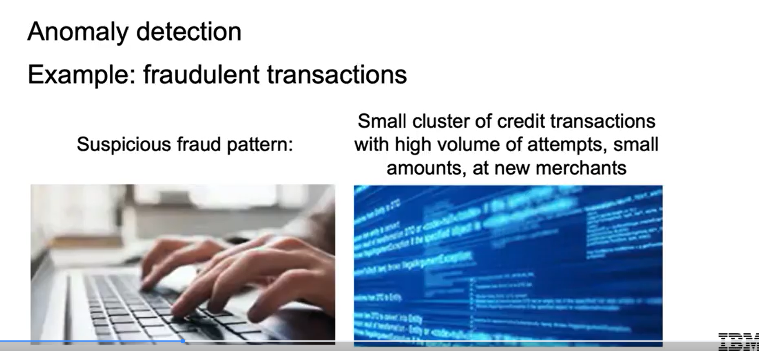
Customer Segmentation
- Businesses can use clustering to segment customers based on behaviors like recency, frequency, and monetary value of visits.
- Demographic-based segmentation can also be performed to tailor marketing strategies for different customer groups.
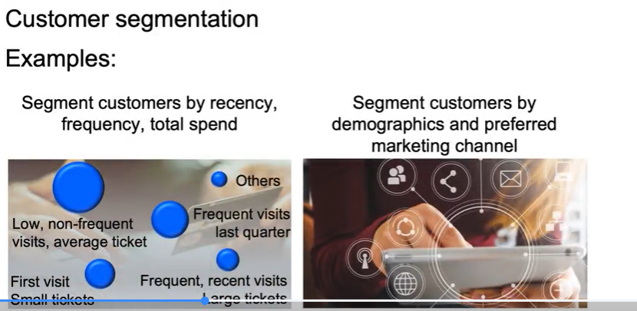
Improving Supervised Learning
- Clustering can enhance supervised learning models by training separate models for identified subsegments, potentially improving overall performance.
- This approach allows for more tailored predictions based on distinct group characteristics.
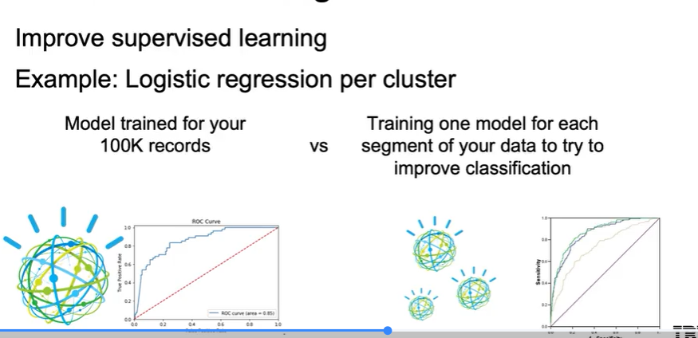
III.Introduction to Clustering
Clustering Basics
- Clustering is used to group users into segments based on specific features, such as the number of visits.
- The example illustrates how to visually identify clusters and the potential need for different numbers of clusters (e.g., two, three, or five).
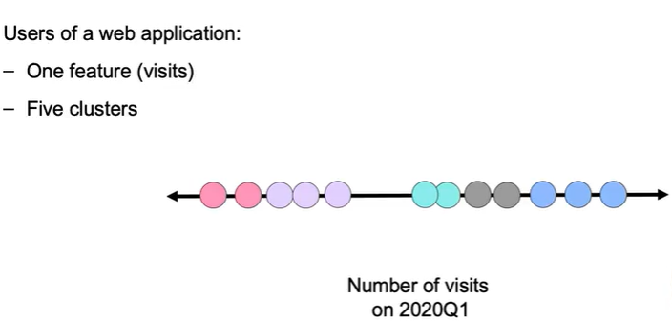
Clustering Algorithms
- The course will cover various clustering algorithms, including K-means, which will be introduced in the next video.
- Understanding how to select the appropriate number of clusters for your data is a key learning objective.
Application in Business
- The ability to segment users effectively can help businesses tailor their strategies and improve customer engagement.
- The course aims to equip learners with the skills to apply clustering techniques in real-world scenarios.
IV.K-Means
K-Means Algorithm Overview
- The algorithm aims to identify clusters based on two features: the number of visits and recency of customer visits.
- It begins by selecting two random points as centroids for the clusters.
Iteration Process
- Each data point is assigned to the nearest centroid, forming initial clusters.
- The centroids are then adjusted to the mean position of the points in each cluster, and this process is repeated until convergence.
Convergence and Sensitivity
- Convergence occurs when centroids no longer move, indicating that the clusters are stable.
- The algorithm's outcome can vary based on the initial choice of centroids, leading to different clustering results.
V.K-Means Initialization
K-means Algorithm Overview
- The algorithm involves selecting centroids, finding the nearest points, and updating centroids based on the average of those points.
- The process continues until the centroids stabilize and no longer move.
Improving Initialization
- Local optima can occur if centroids are initialized too close together, leading to suboptimal clustering.
- A smarter initialization method, K-means++, prioritizes selecting initial centroids that are farther apart to enhance clustering results.
K-means++ Implementation
- The first centroid is chosen randomly, while subsequent centroids are selected based on the squared distance from the existing centroids.
- This method ensures that new centroids are as far away as possible from the already chosen ones, improving the chances of finding a global optimum.
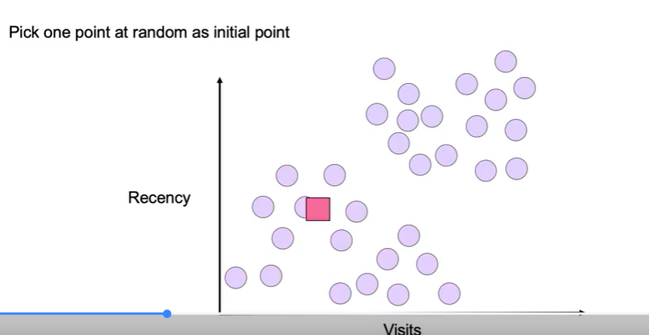
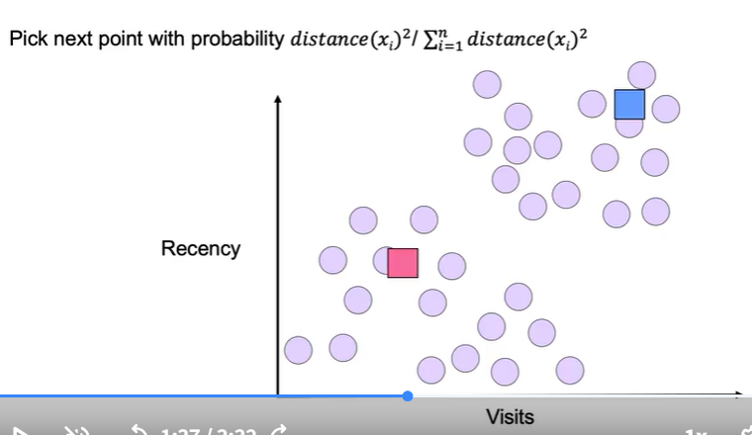
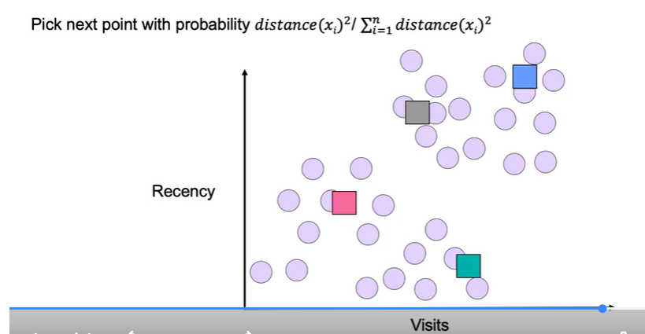
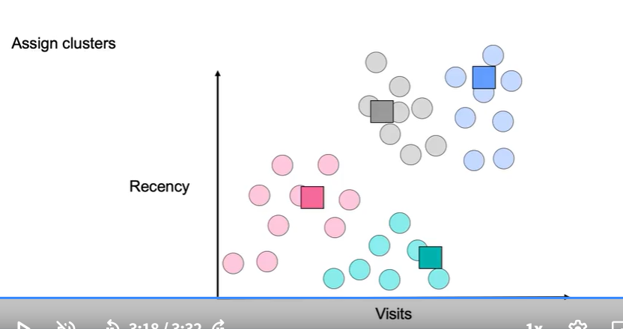
VI.Selecting the Right Number of Clusters in K-Means
Choosing the Number of Clusters
- The number of clusters can be predetermined based on specific objectives, such as hardware limitations or business requirements.
- In cases where the number of clusters is unclear, metrics are needed to help determine the optimal k.
Metrics for Evaluating Clusters
- Inertia measures the total sum of squared distances from each point to its cluster centroid, penalizing spread-out clusters.
- Distortion averages the squared distances from each point to its centroid, allowing for a more stable measure as more points are added.
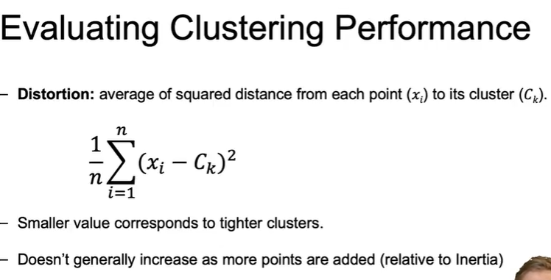
Using Inertia and Distortion
- Inertia increases with more points, while distortion may decrease if new points are closer to centroids.
- The choice between using inertia or distortion depends on whether the focus is on cluster size uniformity or point similarity.
Finding the Best Clustering Model
- To find the best model, the K-means algorithm is run multiple times with different initial configurations, and the resulting inertia or distortion is compared.
- The configuration with the lowest inertia or distortion is selected as the best model.
VII.Elbow method and Applying K-means
Understanding Inertia and Distortion
- Inertia and distortion measure the distance of data points to their centroids, typically decreasing as the number of clusters increases.
- The elbow method identifies an inflection point in the graph of clusters versus inertia/distortion, indicating a suitable number of clusters (K).
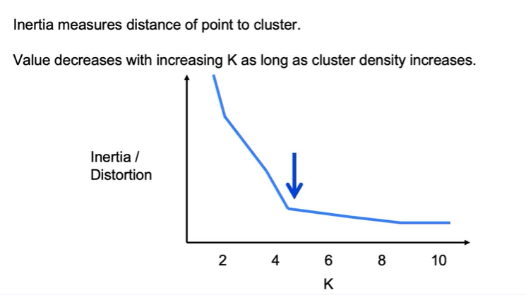
Implementing K-Means in Python
- The K-Means algorithm is initiated by importing the class from sklearn.cluster and setting hyperparameters, including the number of clusters.
- The fitting process involves using the .fit() method on the dataset and predicting clusters for new or existing data.
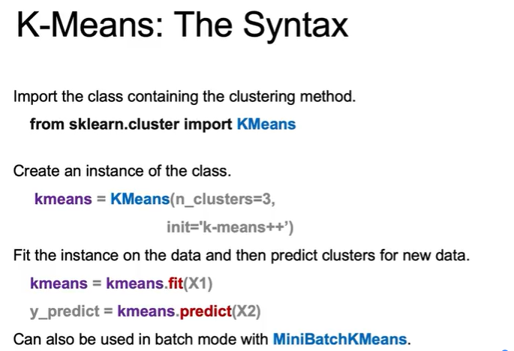
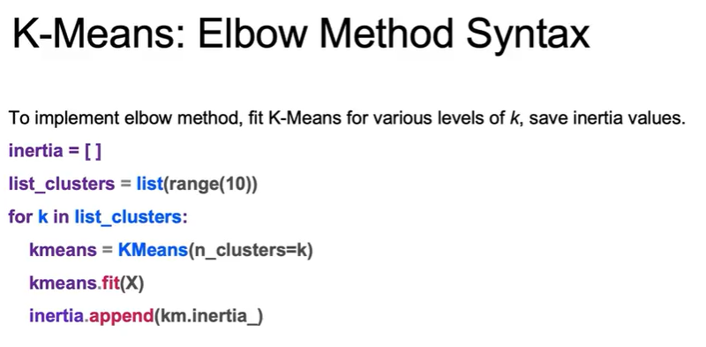
Using the Elbow Method
- To implement the elbow method, K-Means is fitted for various cluster counts, and inertia values are recorded.
- A plot is created with the number of clusters on the x-axis and inertia on the y-axis to visually identify the elbow point, guiding the selection of K.

